THE WILDERNESS OF KADESH-BARNEA AND THE POOL OF BETHESDA
TEXT:
Joh 5:1-15 KJV After this there was a feast of the Jews; and Jesus went up to Jerusalem. (2) Now there is at Jerusalem by the sheep market a pool, which is called in the Hebrew tongue Bethesda, having five porches. (3) In these lay a great multitude of impotent folk, of blind, halt, withered, waiting for the moving of the water. (4) For an angel went down at a certain season into the pool and troubled the water: whosoever then first after the troubling of the water stepped in was made whole of whatsoever disease he had. (5) And a certain man was there, which had an infirmity thirty and eight years. (6) When Jesus saw him lie, and knew that he had been now a long time in that case, he saith unto him, Wilt thou be made whole? (7) The impotent man answered him, Sir, I have no man, when the water is troubled, to put me into the pool: but while I am coming, another steppeth down before me. (8) Jesus saith unto him, Rise, take up thy bed, and walk. (9) And immediately the man was made whole, and took up his bed, and walked: and on the same day was the sabbath. (10) The Jews therefore said unto him that was cured, It is the sabbath day: it is not lawful for thee to carry thy bed. (11) He answered them, He that made me whole, the same said unto me, Take up thy bed, and walk. (12) Then asked they him, What man is that which said unto thee, Take up thy bed, and walk? (13) And he that was healed wist not who it was: for Jesus had conveyed himself away, a multitude being in that place. (14) Afterward Jesus findeth him in the temple, and said unto him, Behold, thou art made whole: sin no more, lest a worse thing come unto thee. (15) The man departed, and told the Jews that it was Jesus, which had made him whole.

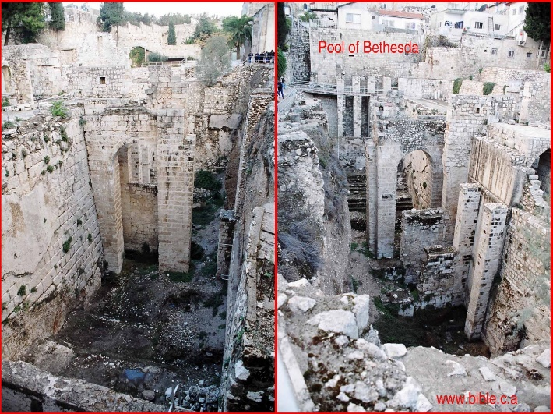

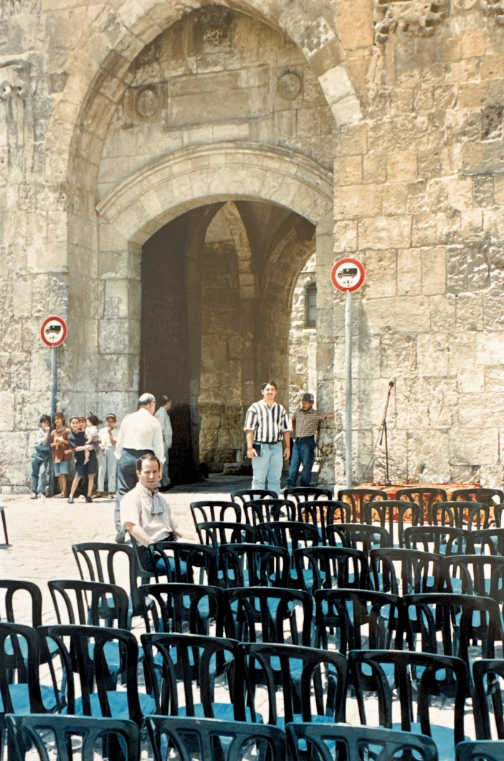

INTRODUCTION:
- The scriptures indicate that the Israelites wandered in the wilderness for forty years.
Num 14:33 KJV And your children shall wander in the wilderness forty years, and bear your whoredoms, until your carcasses be wasted in the wilderness.
  - In Num. 14:33, the years corresponds to the days the spies searched out the land of Israel and gave their report.
  - A person was chosen from the twelve tribes to do reconnaissance in the land of Canaan.
  - Ten spies brought back a negative report but two were positive: Joshua from Ephraim and Caleb from Judah.
Num 14:29 KJV Your carcasses shall fall in this wilderness; and all that were numbered of you, according to your whole number, from twenty years old and upward, which have murmured against me,
  - Num. 14:29 indicates that those twenty years old and up would wander.
- Three passages in Deuteronomy tell us they spent 38 continuous years at Kadesh.
  - As they begin their final approach to the promise land, He contrasts the 40 years it took, with the fact it should have taken only 11 days: "It is eleven days' journey from Horeb by the way of Mount Seir to Kadesh-barnea." Deuteronomy 1:2.
  - Moses tells us they spent most of their time at Kadesh: "So you remained in Kadesh many days, the days that you spent there." Deuteronomy 1:46
  - Finally, Moses tells them they spent 38 years at Kadesh: "Now the time that it took for us to come from Kadesh-barnea until we crossed over the brook Zered was thirty-eight years, until all the generation of the men of war perished from within the camp, as the Lord had sworn to them." Deuteronomy 2:14.
  - In other words, they spent 38 long and unnecessary years parked at Kadesh, when they could have entered the promised land 11 days after leaving Mt. Sinai!
- Bible events that occurred at Kadesh Barnea
  - In 2000 BC, Chedorlaomer, king of Elam captured En-mishpat (Kadesh-barnea): Gen 14:7
  - Miriam died and was buried: Num 20:1
  - Moses strikes the rock, no water: (Meribah or Meribath-kadesh): Num 20:1-5 Ez 47:19; 48:28
  - Korah's rebellion where the earth split open: Num 16:31-34
  - Spies were sent out: Joshua 14:7; Num 13:26 then disobeyed God by trying to enter the promised land when God said they were going to spend 38 years more in the wilderness: Num 14:34,42.
  - Moses asked Edom permission to pass through the land: Num 20:14
  - They spent 38 years in Kadesh: "So you remained in Kadesh many days, the days that you spent there." Deuteronomy 1:46 "Now the time that it took for us to come from Kadesh-barnea until we crossed over the brook Zered was thirty-eight years." Deuteronomy 2:14. "So Israel remained at Kadesh." Judges 11:17
  - Kadesh was one huge graveyard: 1.5 million Hebrews died at Kadesh, everyone over the age of 20: Numbers 14:29-35 (see also: Num 26:64-65; Deut 1:34-35; Psalm 106:26; 1 Cor 10:5)
  - Amaziah recaptures Kadesh (Sela at the time) and renames it Joktheel. 2 Kings 14:7; 2 Chron 25:11-12

